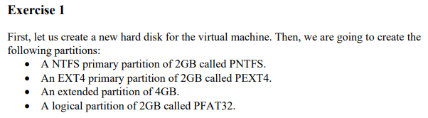

First we are going to create a new 10gb Disk for the virtual machine.

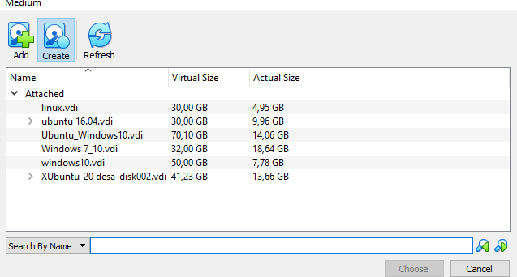

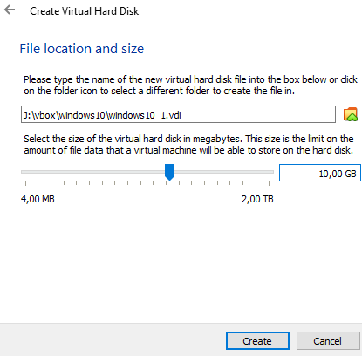

we click choose to put de HDD that we have create in the virtual machine

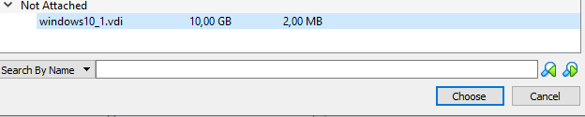

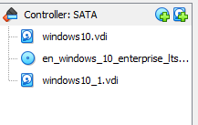

Now we are going to put the Gparted Iso image in the VM:



and start up the machine.

Once upon we are in Gparted menu we are going to create the partition but first we can look the units hdd that we have:

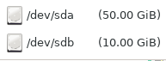

We are going to select de 10Gib disk, and create the partition table:

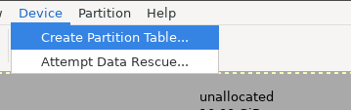

Now in the following we are going to select the MSdos type and click apply:

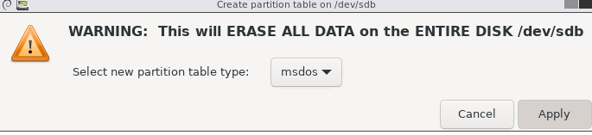

Once up we have create this partition table we have to press left click, new to create a first partition with the following parameters:

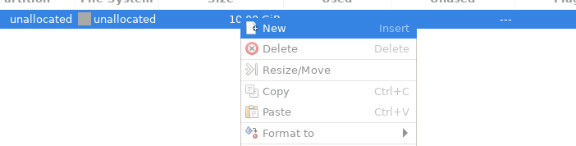

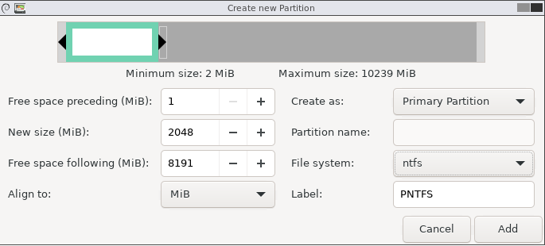

Now we continue with the second partition:

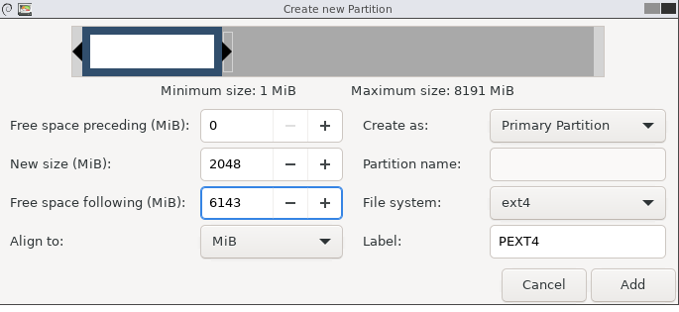

Now we have to create an extended partition using all the available space:

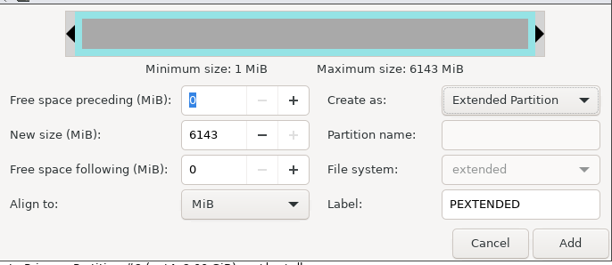

Then we are going to create a Logical partition unit with 2 GB fat32:

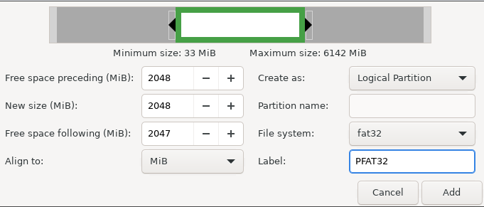

As we can see we have 2GB unallocated space both in the extended partition in the rest of the disk:

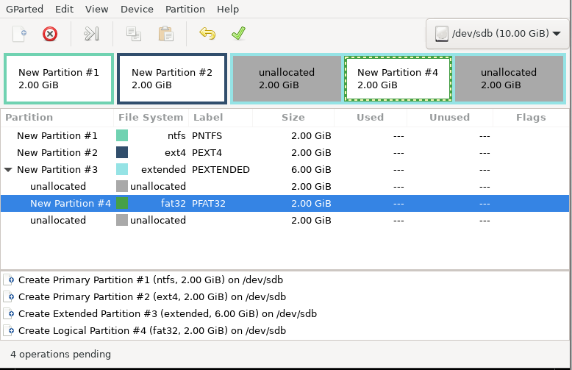

You must save all you did press the apply button:

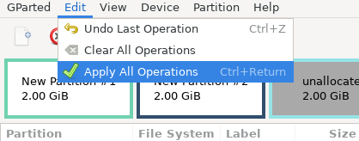

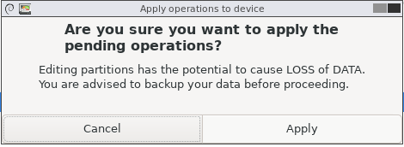

Now we are going to shut down Gparted:

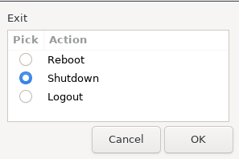

Don’t forget remove the gparted before start the machine.

Now we go to the Disk management to see the partitions:

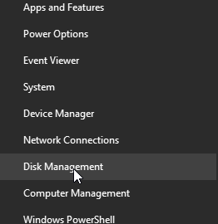

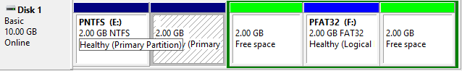

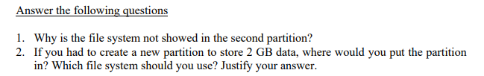

1.R Because Windows 10 can’t recognize EXT4 file system

2.R Depends the type of partition that we want to create, if it is extended or free space.

We can use FAT32, FAT16, NTFS.

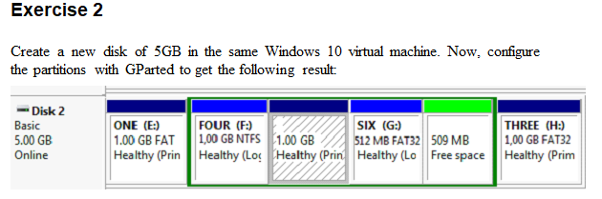For begin the exercise we create a new disk of 5gb and configure it y Gparted:

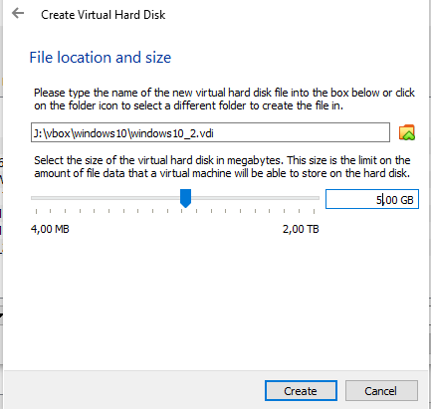

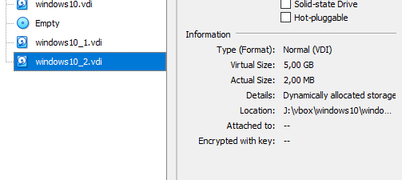

Now we start up the Gparted and choose the new 5gb disk:



Let's create the first partition:

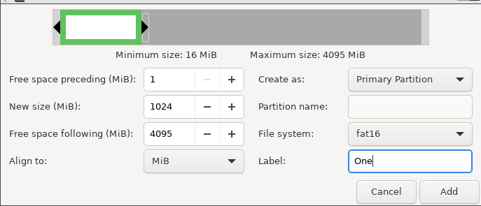

Now the second one we create the extended partition:

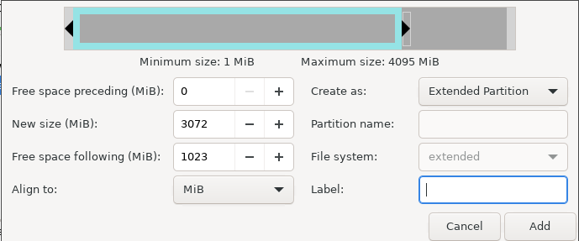

Then we create the FOUR partition:

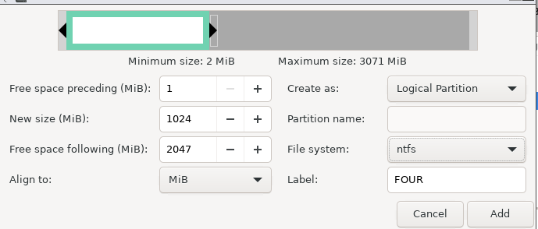

Now the following 1GB partition:

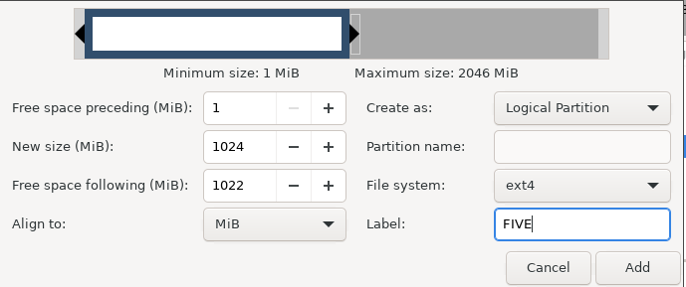

Then a 512 FAT32:

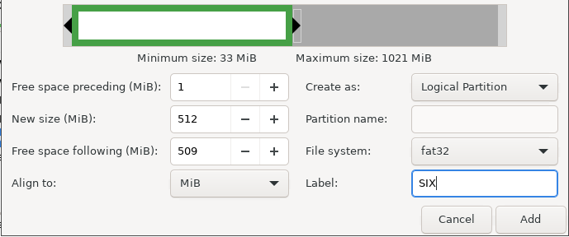

At the end we create the last one:

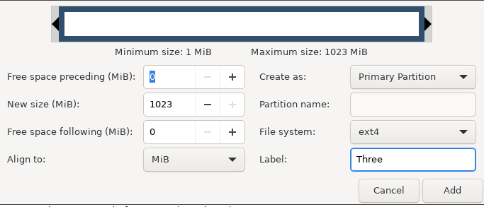

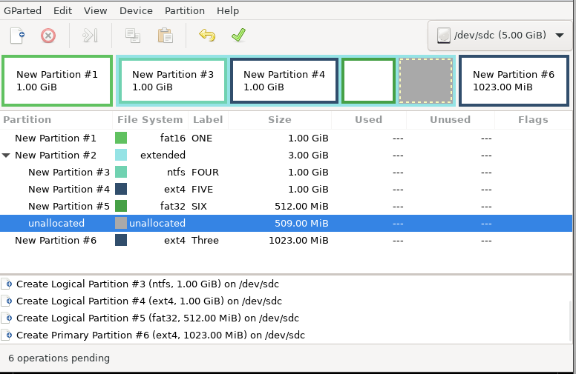

Now we start up windows and go to the Disk management:

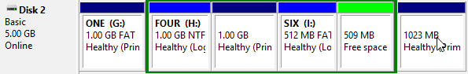

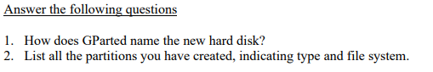

1. GParted name it as /dev/sdc
   1. One 1 GB FAT16
   2. Extended 3 GB
      1. Four 1 GB NTFS
      2. FIVE 1 GB EXT4
      3. SIX 512 GB FAT32
   3. 1023 GB Fat32